**8 Infrared obstacle avoidance with backdrop**

**The purpose of the experiment:**

The difference between this course and the basic obstacle avoidance course is that after the obstacles are detected by the left and right infrared obstacle avoidance probes, the smart car retreats and the direction of the obstacles is avoided.

**Precautions:**

1.Before conducting the experiment, you need to debug the adjustable resistors SW1 and SW2 in front of the smart car, as shown below.

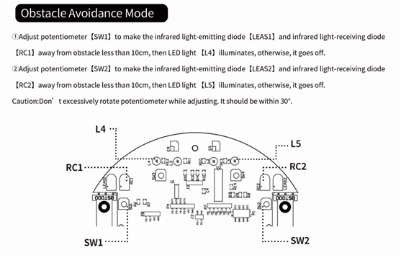

2. This experiment must be carried out in an environment without outdoor light, and it is also necessary to pull curtains to block outdoor light indoors.

**List of components required for the experiment:**

Arduino Smart Car* 1  
USB cable* 1  
Active buzzer* 1  
DuPont Line* 13  
Breadboard* 1  
Button * 1

10K resistor * 1

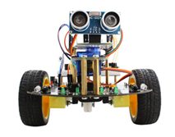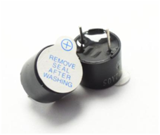    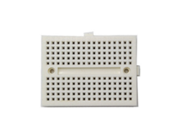          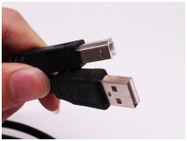

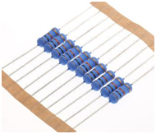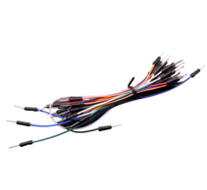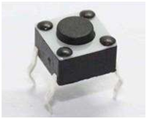

**Experimental code analysis:**

//============================yahboom===========================

//   Intelligent car infrared obstacle avoidance experiment3(Obstacle avoidance with backdrop)

//===============================================================

int Left_motor_back=9;     //(IN1)

int Left_motor_go=5;       //(IN2)

int Right_motor_go=6;      //(IN3)

int Right_motor_back=10;   //(IN4)

int key=A0;//Define the key A0 interface

int beep=A1;//Define the buzzer A1 interface

const int SensorRight = A2;        //Right tracking infrared sensor(P3.2 OUT1)

const int SensorLeft = A3;        //Left tracking infrared sensor(P3.3 OUT2)

const int SensorLeft_2 = A4;     //Left infrared sensor(P3.4 OUT3)

const int SensorRight_2 = A5;    //Right infrared sensor(P3.5 OUT4)

int SL;      //Left tracking infrared sensor state

int SR;      //Right tracking infrared sensor state

int SL_2;    //Left infrared sensor state

int SR_2;    //Right infrared sensor state

void setup()

{

  //Initialize the motor drive IO for output mode

  pinMode(Left_motor_go,OUTPUT); // PIN 5 (PWM)

  pinMode(Left_motor_back,OUTPUT); // PIN 9 (PWM)

  pinMode(Right_motor_go,OUTPUT);// PIN 6 (PWM)

  pinMode(Right_motor_back,OUTPUT);// PIN 10 (PWM)

  pinMode(key,INPUT);//Define the key interface for the input interface

  pinMode(beep,OUTPUT);

  pinMode(SensorRight, INPUT);   //Define Right tracking infrared sensor for the input interface

  pinMode(SensorLeft, INPUT);    //Define left tracking infrared sensor for the input interface

  pinMode(SensorRight_2, INPUT); //Define right infrared sensor for the input interface

  pinMode(SensorLeft_2, INPUT);  //Define left infrared sensor for the input interface

}

//=======================The basic action of car=========================

//void run(int time)

void run()

{

  digitalWrite(Right_motor_go,HIGH);  //right motor go

  digitalWrite(Right_motor_back,LOW);

  analogWrite(Right_motor_go,100);//PWM ratio 0~255 speed control,

                                 //the difference of left and right wheel slightly increase or decrease

  analogWrite(Right_motor_back,0);

  digitalWrite(Left_motor_go,HIGH);  // left motor go

  digitalWrite(Left_motor_back,LOW);

  analogWrite(Left_motor_go,100);//PWM ratio 0~255 speed control,

                                 //the difference of left and right wheel slightly increase or decrease

  analogWrite(Left_motor_back,0);

  //delay(time * 100);    //execution time, can be adjusted

}

void brake(int time)

{

  digitalWrite(Right_motor_go,LOW);

  digitalWrite(Right_motor_back,LOW);

  digitalWrite(Left_motor_go,LOW);

  digitalWrite(Left_motor_back,LOW);

  delay(time * 100);//execution time, can be adjusted

}

//void left(int time)

void left()         //turn left(left wheel stop,right wheel go)

{

  digitalWrite(Right_motor_go,HIGH);   //right motor go

  digitalWrite(Right_motor_back,LOW);

  analogWrite(Right_motor_go,100);

  analogWrite(Right_motor_back,0);     //PWM ratio 0~255 speed control

  digitalWrite(Left_motor_go,LOW);

  digitalWrite(Left_motor_back,LOW);

  analogWrite(Left_motor_go,0);

  analogWrite(Left_motor_back,0);     //PWM ratio 0~255 speed control

  //delay(time * 100);      //execution time, can be adjusted

}

void spin_left(int time)         //left rotation(left wheel back，right wheel go)

{

  digitalWrite(Right_motor_go,HIGH);   //right motor go

  digitalWrite(Right_motor_back,LOW);

  analogWrite(Right_motor_go,100);

  analogWrite(Right_motor_back,0);     //PWM ratio 0~255 speed control

  digitalWrite(Left_motor_go,LOW);     //left motor back

  digitalWrite(Left_motor_back,HIGH);

  analogWrite(Left_motor_go,0);

  analogWrite(Left_motor_back,100);   //PWM ratio 0~255 speed control

  delay(time * 100);   //execution time, can be adjusted

}

//void right(int time)

void right()        //turn right (right wheel stop,left wheel go)

{

  digitalWrite(Right_motor_go,LOW);

  digitalWrite(Right_motor_back,LOW);

  analogWrite(Right_motor_go,0);

  analogWrite(Right_motor_back,0);  //PWM ratio 0~255 speed control

  digitalWrite(Left_motor_go,HIGH); //left motor go

  digitalWrite(Left_motor_back,LOW);

  analogWrite(Left_motor_go,100);

  analogWrite(Left_motor_back,0);   //PWM ratio 0~255 speed control

  //delay(time * 100);       //execution time, can be adjusted

}

void spin_right(int time)        //right rotation(right wheel back,left wheel go)

{

  digitalWrite(Right_motor_go,LOW);

  digitalWrite(Right_motor_back,HIGH); //right motor back

  analogWrite(Right_motor_go,0);

  analogWrite(Right_motor_back,100);   //PWM ratio 0~255 speed control

  digitalWrite(Left_motor_go,HIGH);    //left motor go

  digitalWrite(Left_motor_back,LOW);

  analogWrite(Left_motor_go,100);

  analogWrite(Left_motor_back,0);     //PWM ratio 0~255 speed control

  delay(time * 100);   //execution time, can be adjusted

}

void back(int time)

{

  digitalWrite(Right_motor_go,LOW);  //right motor back

  digitalWrite(Right_motor_back,HIGH);

  analogWrite(Right_motor_go,0);

  analogWrite(Right_motor_back,100); //PWM ratio 0~255 speed control

  digitalWrite(Left_motor_go,LOW);   //left motor back

  digitalWrite(Left_motor_back,HIGH);

  analogWrite(Left_motor_go,0);

  analogWrite(Left_motor_back,150);  //PWM ratio 0~255 speed control

  delay(time * 100);     //execution time, can be adjusted

}

//==========================================================

void keysacn()

{

  int val;

  val=digitalRead(key);//Read the value of the  port 7 level to the val

  while(!digitalRead(key))//When the key is not pressed, circulate all the time

  {

    val=digitalRead(key);//This sentence can be omitted and the circulate can run away.

  }

  while(digitalRead(key))//This sentence can be omitted and the circulate can run away.

  {

    delay(10);

    val=digitalRead(key);//Read the value of the port 7 level to the val

    if(val==HIGH)  //Judge whether the key is pressed again

    {

      digitalWrite(beep,HIGH);         //buzzer sound

      while(!digitalRead(key))            //Judge whether the key isreleased

        digitalWrite(beep,LOW);             //buzzer no sound

    }

    else

      digitalWrite(beep,LOW);          //buzzer no sound

  }

}

void loop()

{

  keysacn();       //Call key scan function

  while(1)

  {

    //There is a signal is LOW , no signal is HIGH

    SR_2 = digitalRead(SensorRight_2);

    SL_2 = digitalRead(SensorLeft_2);

    if (SL_2 == HIGH&&SR_2==HIGH)

      run();   //Call run function

    else if (SL_2 == HIGH & SR_2 == LOW)

    //There is an obstacle on the right,return signal,turn left.

        left();

    else if (SR_2 == HIGH & SL_2 == LOW)

    //There is an obstacle on the left,return signal,turn right

      right();

    else // There are obstacles on both sides , back

    {

       back(4.5);

      spin_right(4.5);//right retation，adjust direction

    }

  }

}

**Experimental steps:**

1. We need to open the code of this experiment: **avoid3.ino,**click“**√**” under the menu bar to compile the code, and wait for the word "**Done compiling** " in the lower right corner,as shown in the figure below.

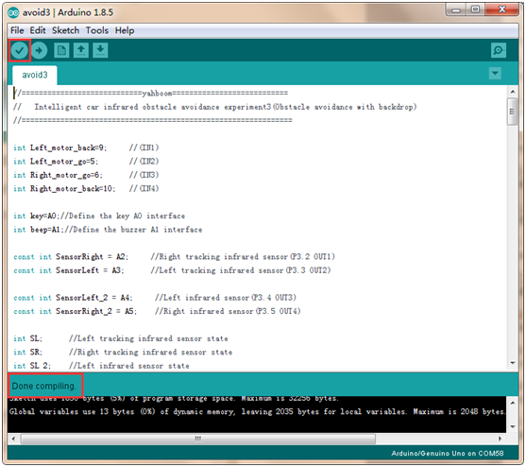

2. In the menu bar of Arduino IDE, we need to select 【Tools】---【Port】--- selecting the port that the serial number displayed by the device manager just now, as shown in the figure below.

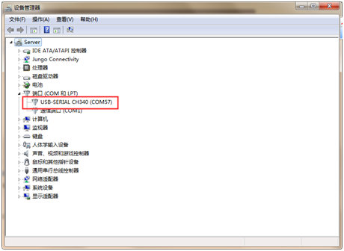

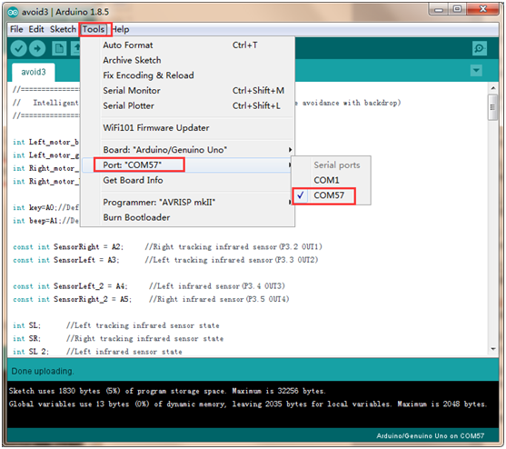

3. After the selection is completed, you need to click “**→**”under the menu bar to upload the code to the Arduino UNO board. When the word “**Done uploading**” appears in the lower left corner, the code has been successfully uploaded to the Arduino UNO board, as shown in the figure below.

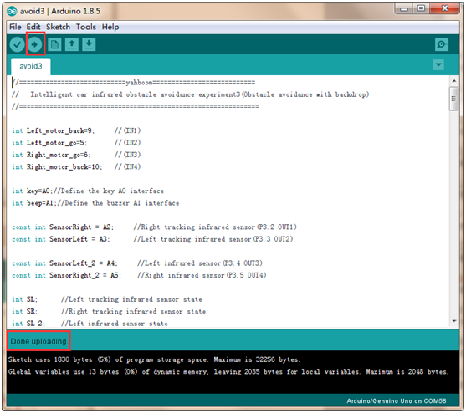

4.Please wire the Smart Car as shown below.

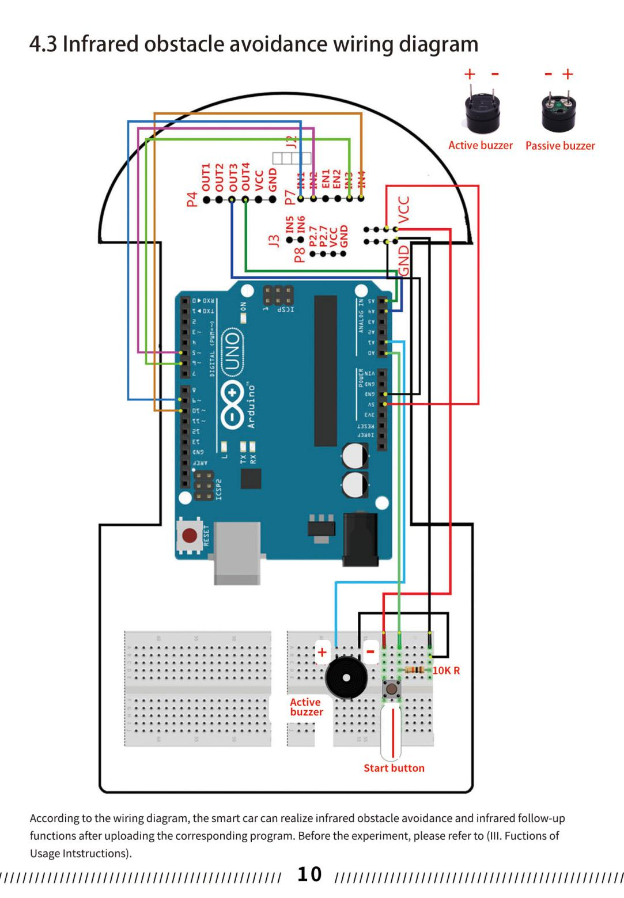

5. Use the carton to simulate the obstacles on the ground, put the smart car that has uploaded the program **avoid.ino** on the ground, press the start button of the tail of the car, if the smart car detects that there is no obstacle in front, the car goes straight. If an obstacle is detected in the left front, the car turns right to avoid obstacles. If the right front right obstacle is detected, the cart turns left to avoid obstacles. If it is detected that there are obstacles on the left and right sides, the smart car will retreat and turn around to avoid obstacles.